Error: Reference source not found
–
Document ID: 0000.doc
Author(s): TN Team
Version: 0.2
Date: April 14, 2024

1. Objective and Scope 3
2. Project End Users 3
3. Features 4
3.1 Responsive Navigation Bar 4
3.2 Stunning Collections 4
3.3 Join Our Newsletter 4
3.4 Screen Size Optimization 4
3.5 Dynamic Search Bar 6
3.6 Contact Us 7
3.7 Reports ……………………………………………………………………………………………………………………………….8

Objective and Scope
The objective of Nostra is to deliver a user-friendly dress shopping experience, featuring a responsive interface, highlighted "Most Wanted" and "New Arrivals," and a "Join Newsletter" option, with efficient browsing through a dynamic search bar. The scope of the Nostra E-commerce site includes the following basic features:
- The homepage of Nostra will feature a responsive navigation bar, allowing users to easily access key sections like "Home," "Collection," and "Contact Us."
- Prominent sections for "Most Wanted" and "New Arrivals" will be showcased on the homepage, enhancing user engagement and facilitating exploration of trending products.
- A "Join Newsletter" option will be provided on the homepage, enabling users to subscribe for updates and promotions.
- Through media queries, the website layout will adapt across different devices, ensuring optimal viewing experience.
- Upon navigating to the collection page, JavaScript functionality will dynamically enable a search bar, enabling users to efficiently browse and search for specific products within the collection.
- Reports

Project End Users
The project end users include:
- Customers seeking trendy outfits for various occasions.
- Gift buyers searching for stylish dresses for friends or family.
- Individuals looking to purchase dresses online for themselves or others.

Features

Responsive Navigation Bar
Design a user-friendly navbar on the homepage featuring links to essential sections like "Home," "Collection," and "Contact Us," ensuring effortless navigation throughout the website on various devices.

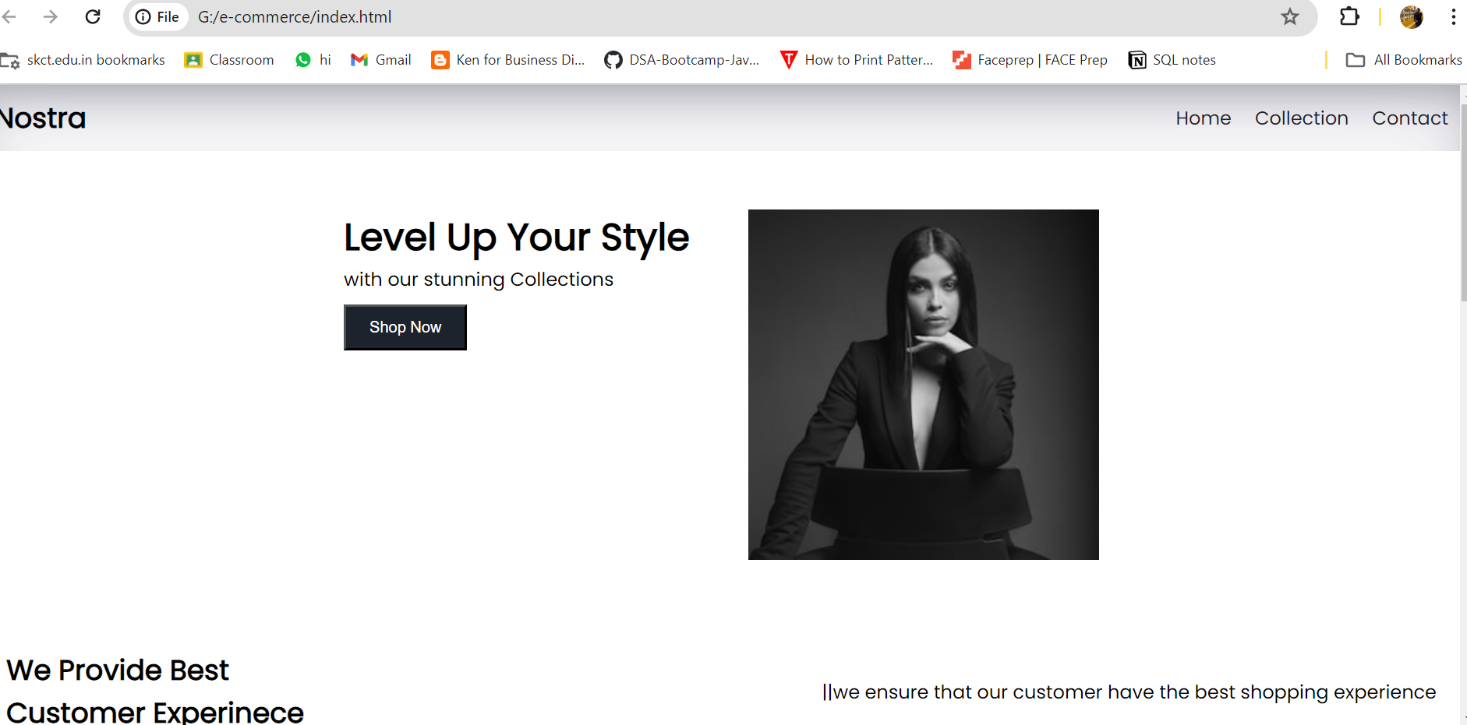

Stunning Collections
- Showcase "Most Wanted" and "New Arrivals" prominently on the homepage to attract user attention and promote popular products.
- Include prominent "Shop Now" buttons beneath each collection, enabling users to conveniently browse and purchase items from their preferred collection with just a click.
- Facilitate seamless exploration of diverse collections, catering to varied preferences, thereby fostering increased user engagement.

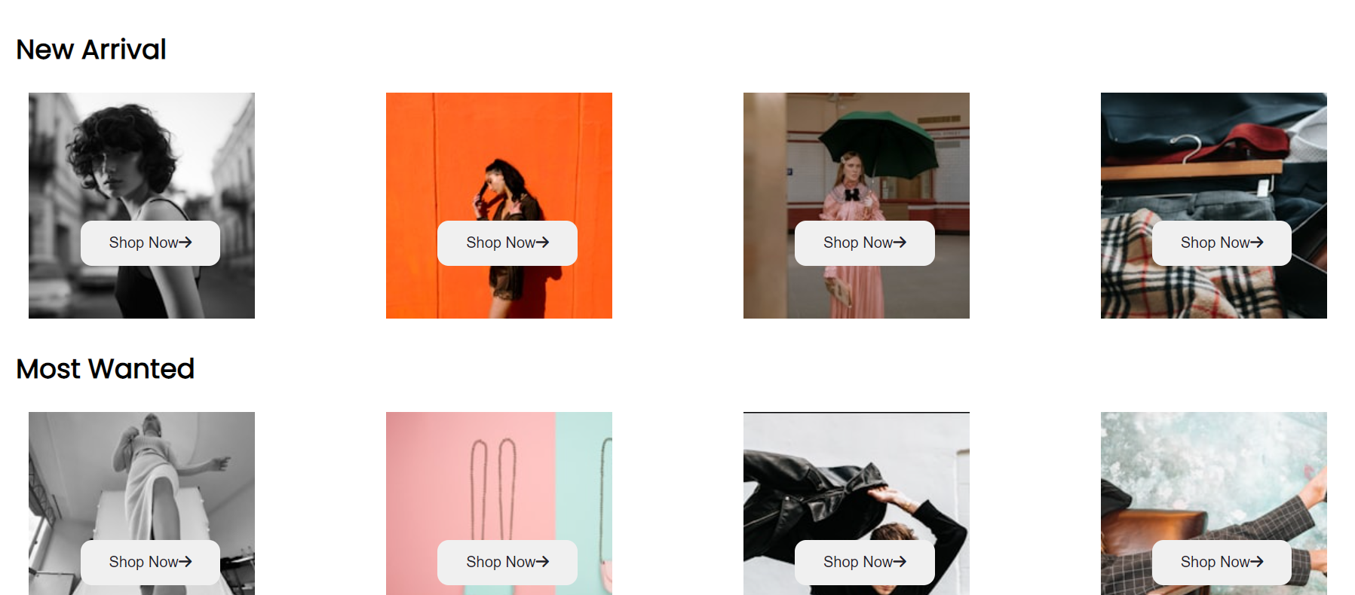

Join Our Newsletter
- Sign in our site to our newsletter for exclusive discounts and updates, ensuring you're the first to know about our latest offers and promotions.
- Stay informed and never miss out on great deals by joining our newsletter community today.
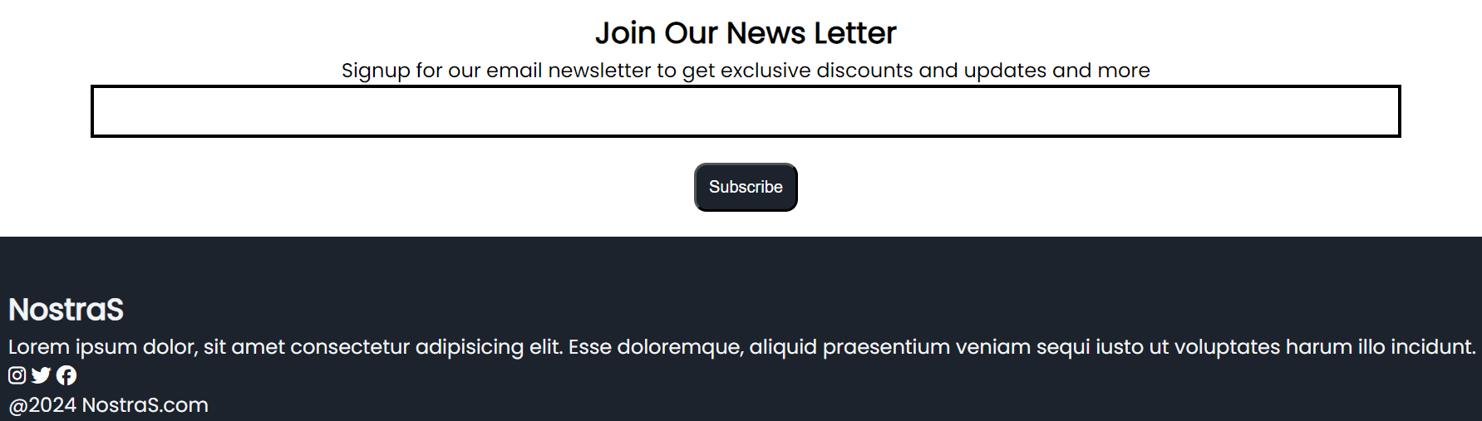

Screen Size Optimization
Utilize media queries to ensure that the website layout adapts seamlessly across various devices, providing an optimal viewing experience for users accessing the site on different screen sizes.
- Responsive Layout: Utilize media queries to create a flexible and adaptive layout that adjusts smoothly to different screen sizes, ensuring optimal viewing on devices ranging from desktop computers to mobile phones.
- Improved User Experience: Enhance user satisfaction by providing a consistent and intuitive browsing experience across various devices, reducing the need for resizing, scrolling, or zooming.
- Accessibility Across Devices: Ensure that all users, regardless of the device they use, can easily access and interact with the website's content, leading to increased engagement and retention.
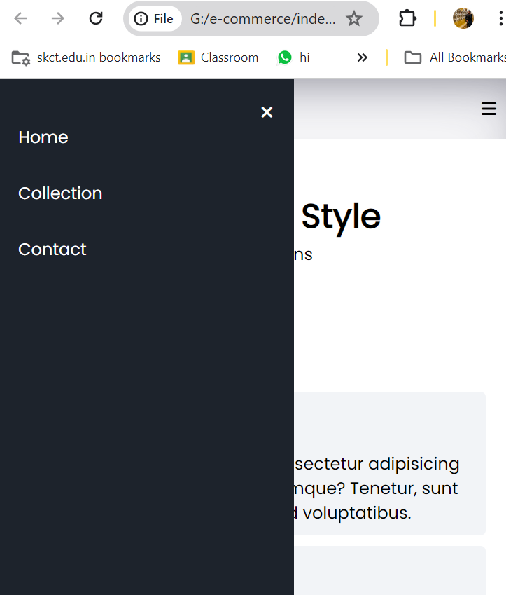

Dynamic Search Bar
- Add a dynamic search bar to the collection page using JavaScript, helping users find items they want faster.
- Allow users to search for specific products within the collection easily, saving time and effort.
- Enhance user satisfaction by providing a convenient search feature, leading to a smoother shopping experience and happier customers.

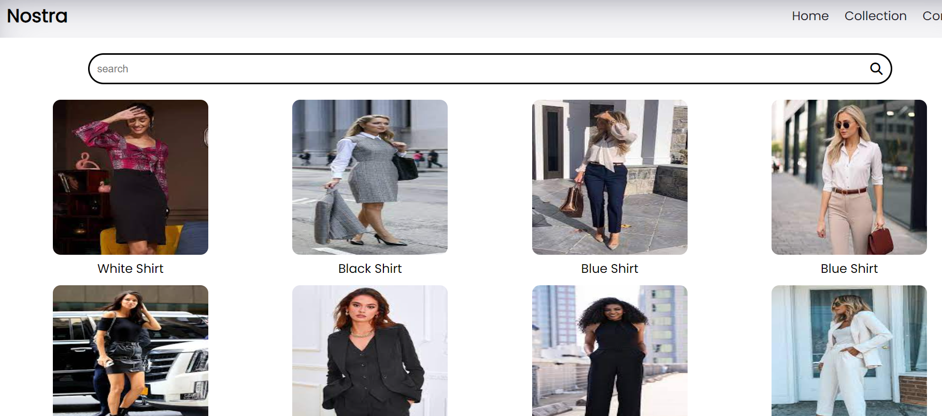

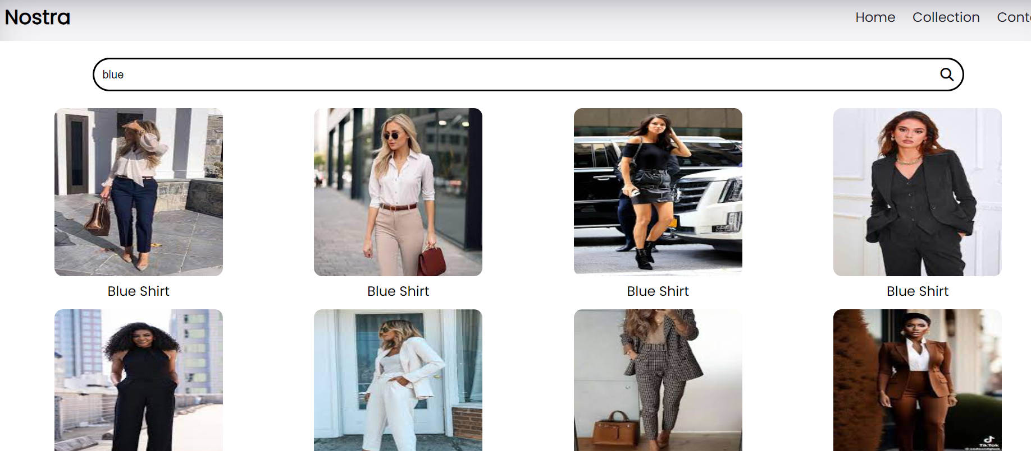

Above image is search section functionality on the website. It outlines the process where users can search for dresses based on their preferences.
- The search functionality includes validation to ensure that users provide complete and accurate search terms, improving the relevance of search results.
- With the availability of various search filters and the ability to quickly find desired images, users experience greater convenience and efficiency when browsing the website, leading to improved satisfaction and engagement.

Contact Us
- Create a "Contact Us" page featuring fields for users to input their name, email, and message, facilitating easy communication with the website.
- Ensure that contact information is easily accessible from any page on the website.
- Upon submission of the contact form, automatically redirect users to the homepage, ensuring a seamless transition and allowing them to continue browsing without interruption.
- Ensure timely responses to user queries to enhance user satisfaction and support experience.
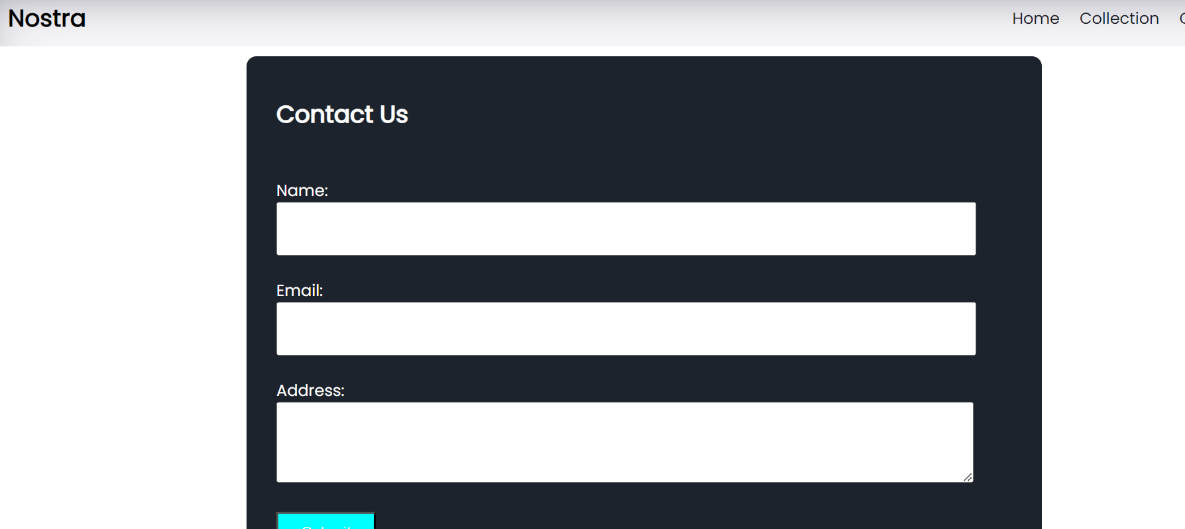

Reports
The Nostra e-commerce dress website provides users with an intuitive platform to register for dress purchases, select preferred packages, and access detailed reports on their orders and preferences. With streamlined registration, diverse product options, and robust reporting features, users can effortlessly navigate their shopping experience and track their purchase history effectively.

